**ACCESSING AZURE VM**

In order to access Azure VM , kindly follow the below steps : -

**Step1: Login to Azure Portal.**

* Once you are logged in, search for Virtual machine under All resources in the portal dashboard. And click on the DialMalawi-VM1 Virtual machine provided.

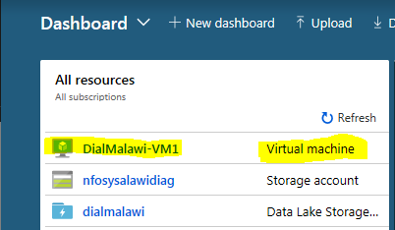

* You will be redirected to a page similar to shown below, Please click on the connect option as highlighted in the snapshot.

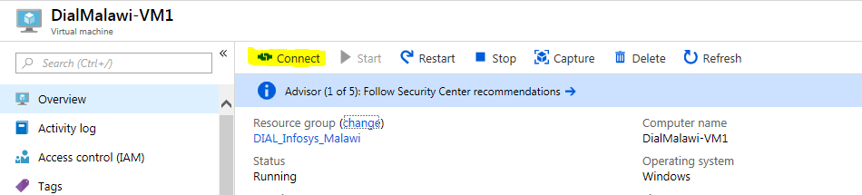

* Connect to VM pop will come, kindly download the RDP file and save it to your local machine.

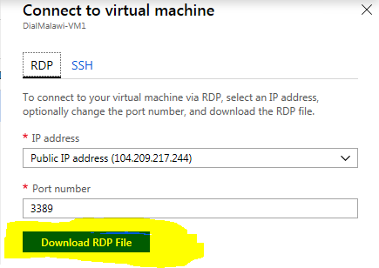

* Open the downloaded RDP File and click on the “connect” option as shown below.

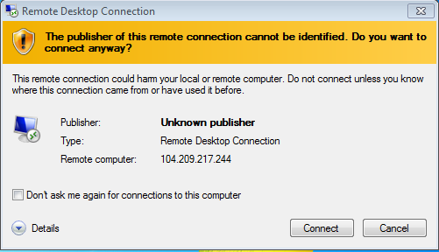

* Provide username and password to connect to the VM.

Username : dialadmin

Password : T};K8Cn-:(age/m+

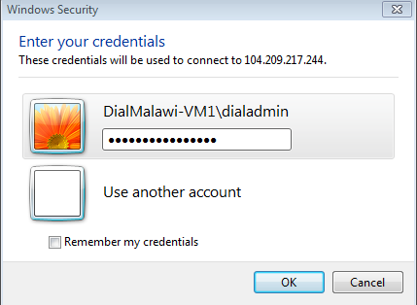

Click on Yes and proceed.

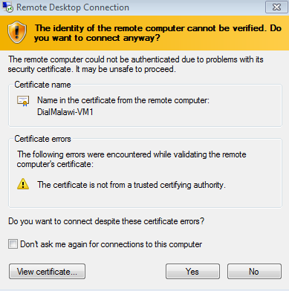

You are now connected to Azure VM